**Scoping II: Computational Analysis**

**Technology deploymet**

Roslyn Walker, Student number 45149631

Proof of Concept FOAR705 Digital Humanities

Due 2.00pm. 23 August 2019

Computational thinking is made up of four parts:

(1) Decomposition

(2) Pattern recognition

(3) Pattern generalisation and abstraction

(4) Algorithm design

**1. Decomposition**

In my Scoping Paper I, I identified the objective of the project to build a repository for images online from social media that will form data for my thesis. Copyright management is in the scope of this project. The tasks include developing a dataset of images for cataloguing and adding contextual information about visual works in an archive collection (that is thematic tagging, making connections between objects, people, dates and places).

1. Capture material through thematic tagging to enable virtual exhibition display of content. I would like to curate these materials as a virtual exhibition.

2. Prepare a list of data types drafted as a tabular list in a word document and place this information into a spreadsheet format (Excel). The data types will be selected from standard usage terms of archive repositories. Description of images of other fields for the content records.

3. Output: coding sheet of terms, Readme files, control vocabulary to make the task of tagging digital records easier when posting them to the repository as visual objects.

4. Data source files: Images sourced from social media hashtag publics on Instagram and Twitter.

5. Copyright restrictions on content may prevent the use of this material.

6. It would be great if I could automate the application of data tags and classification to the digitised record. I would like a tool that automatically applies tagging to the digital record.

**2. Pattern Recognition**

1. Initial setup format of data tables and resolve formatting issues for tabular data.
2. Source images and resolve copyright issues.
3. Discovery process for image use consider links or export options.
4. Filter, sort and display of image and descriptive fields.

**2. Algorithm Design**

Capturing material through thematic tagging to enable virtual exhibition display of content.

Images tagged in hashtag publics on social media platforms: [#FridaysForFuture](https://twitter.com/hashtag/FridaysForFuture?src=hashtag_click) [#YouthStrike4Climate](https://twitter.com/hashtag/YouthStrike4Climate?src=hashtag_click) [#ClimateEmergency](https://twitter.com/hashtag/ClimateEmergency?src=hashtag_click) [#GretaThunberg](https://twitter.com/hashtag/GretaThunberg?src=hashtag_click) [#climatejustice](https://twitter.com/hashtag/climatejustice?src=hashtag_click) [**#ClimateStrike**](https://twitter.com/hashtag/ClimateStrike?src=hashtag_click) [#ExtinctionRebellion](https://twitter.com/hashtag/ExtinctionRebellion?src=hashtag_click) and #ClimateHoax #ClimateDenial

**3. Possible solutions**

Consideration to use a combination of the application of existing platforms and systems:

(1) https://tropy.org/ research photo tool locate archival sources to writing about them.

(2) Document management system (CMS or DMS)

(3) Bibliography software like Zotero

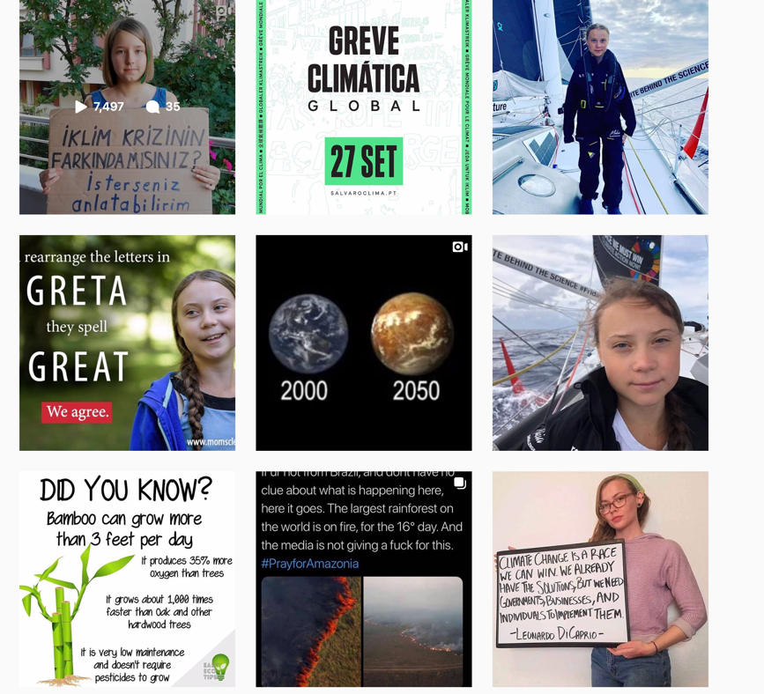

source: #schoolstrike4climate, 22 August 2019

56,256 posts

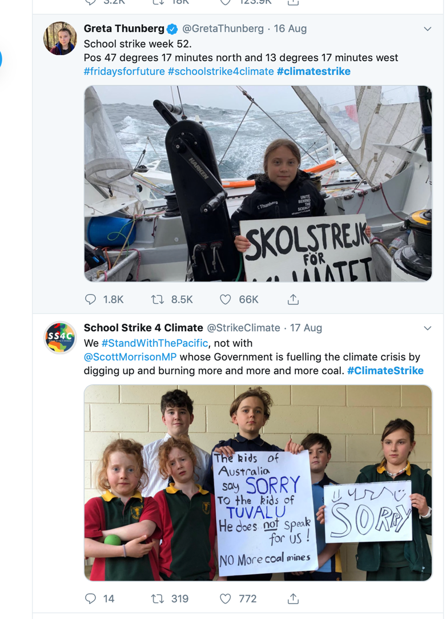

Source: Twitter #ClimateStrike 22 August 2019